**Name : PRIYADHARSHINI S**

**Email Id :** priyastalin033@gmail.com 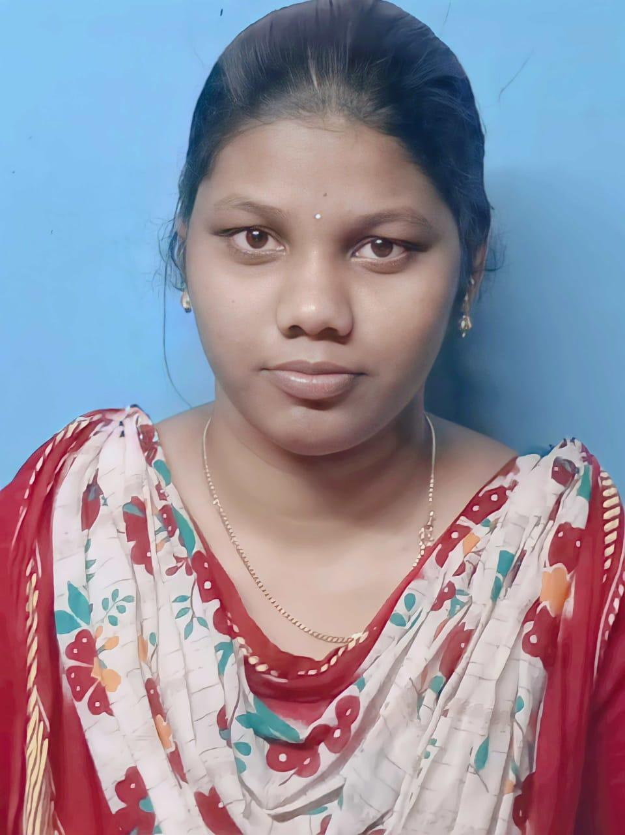

**Mobile No :** 9363650071

**Address :** 18-b Ubari Santhu,KollamPattarai Street,

Pethanaickenpalayam(tk),Salem(dt),

Pincode-636109.

**CAREER OBJECTIVE**

To become a successful engineer with a growth mindset and a dedication to continuously learning skill sets for the development of innovative solutions.

**ACADEMIC QUALIFICATION**

| **COURSE** | **INSTITUTION** | **BOARD /**  **UNIVERSITY** | **PERCENTAGE / CGPA** | **YEAR OF**  **PASSING** |
| --- | --- | --- | --- | --- |
| BE  [CSE] | Muthayammal College Of Engineering , Rasipuram. | Anna University | 7.6  (CGPA) | 2025  (Pursuing) |
| HSC | Government Girls Higher SecondarySchool,  Pethanaickenpalayam. | State Board | 79.19 | 2021 |
| SSLC | Government Girls Higher SecondarySchool,  Pethanaickenpalayam. | State Board | 69.8 | 2019 |

**SOFTWARE PROFICIENCIES & LANGUAGES**

**TechnicalSkills :** JAVA

**SoftwareKnown :** Visual Studio Code

**MINI PROJECT**

**Title :** EcommerceStore.

**Language** : HTML,CSS and JAVASCRIPT.

**Software**:Visual Studio code

**Objective :The objective of an ecommerce store is to increase sales , improve customer satisfaction , boost website traffic and build brand awareness**

**INTERNSHIP**

● Completed internship on **“Internet Of Things”** conducted by Calliber Embedded Technology, Salem.

**WORKSHOP**

● Attended a workshop on **“Skills Needed For Full Stack Developer”** held at KSR Engineering College Tiruchengode, Tamil Nadu.

**INTERPERSONAL SKILLS**

● Hard Worker

● Team Management

● Adaptability

**PERSONAL DETAILS**

Father’s Name **:** Mr.Stalin.M

Mother’s Name **:** Mrs.Menaka.S

Date.Of.Birth **:** 03/July/2003

Languages Known **:** Tamil,English(Read/Write/Speak).

**DECLARATION**

I hereby declare that all the information provided above is true and accurate to the best of my knowledge.

**Date :**

**Place : PRIYADHARSHINI S**